Exp.No:31
31. Morphological operations based on OpenCV using Opening technique.

Aim:
To perform morphological Opening operation on an image using OpenCV.
Procedure:
- Read the input image.
- Create a structuring element.
- Apply erosion followed by dilation.
- Display the original and opened images.
- Save the output.
Program:
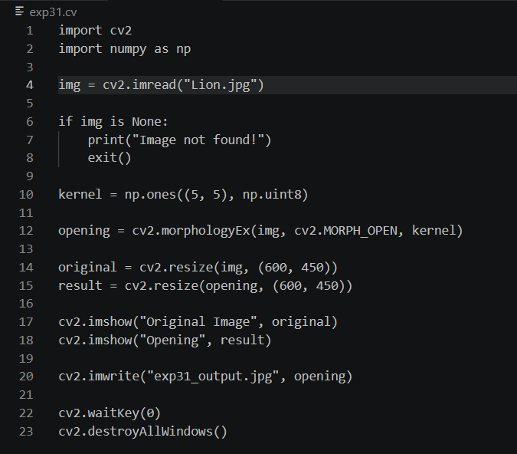

Input:
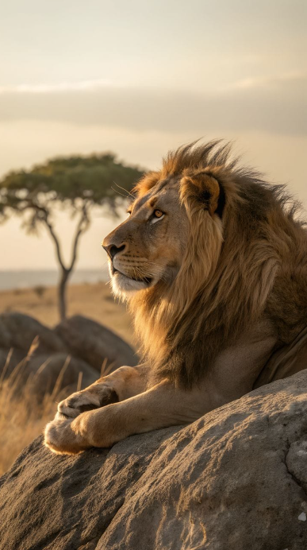
Output:
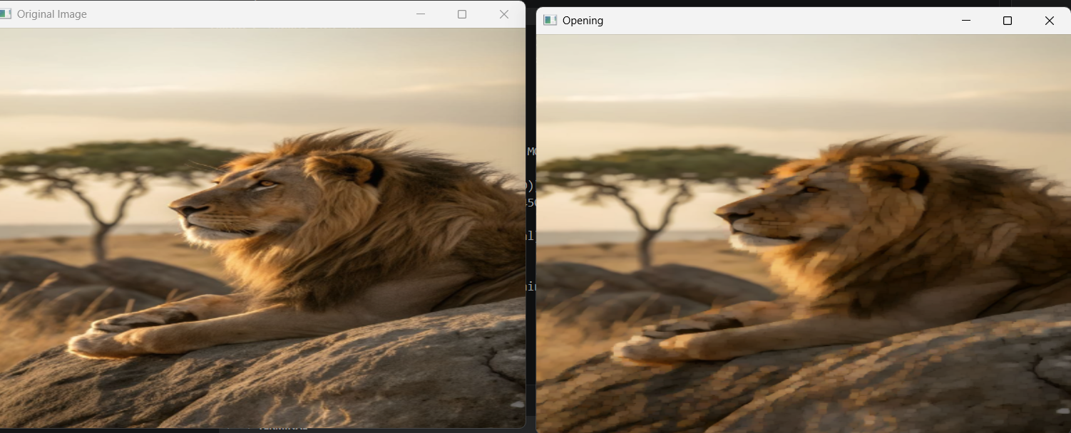
Result:
The morphological Opening operation was successfully performed on the image.

